- We expect the Monetary Policy Committee will keep Bank Rate at 4.75% at its next meeting on December 19. The MPC has settled into a cut-hold tempo and the data published over the past six weeks is unlikely to have convinced the committee to increase the pace of rate cuts.
- The seven potential swing voters appear to have adopted the MPC's mid-range inflation scenario as their baseline. Some members have suggested they see the risks being tilted towards a more benign outcome, but we doubt they feel strongly enough to vote for back-to-back cuts at this stage. We expect an 8-1 vote to keep rates on hold.
The Bank of England's Monetary Policy Committee has settled into a cut-hold tempo for policy loosening. We think the chances that the committee will break this pattern at the December meeting are very low. Our focus will be on whether any of the members who have recently made more dovish comments feel the need to vote for back-to-back cuts.
Most MPC members have made public comments since the November meeting, and bulk of the commentary has been framed around the BoE's three inflation scenarios. The broad consensus on the mid-range scenario has been unsurprising, but we have learned more about how some members view the balance of risks (Chart 1).
External member Alan Taylor and Deputy Governor Dave Ramsden suggested they place relatively high weights on the more dovish scenario, which assumes inflation persistence dissipates without a marked rise in unemployment. But they were vague on what developments could encourage them to make this scenario their baseline and switch to voting for consecutive cuts.
Clare Lombardelli argued that while the risks to inflation are broadly balanced, the potential consequences of the upside risks are more serious. This suggests her bar to voting for a more aggressive approach to loosening policy is set higher (Table 1 shows our analysis of recent comments by MPC members).

Chart 1: There's a broad consensus around the MPC's mid-range inflation scenario
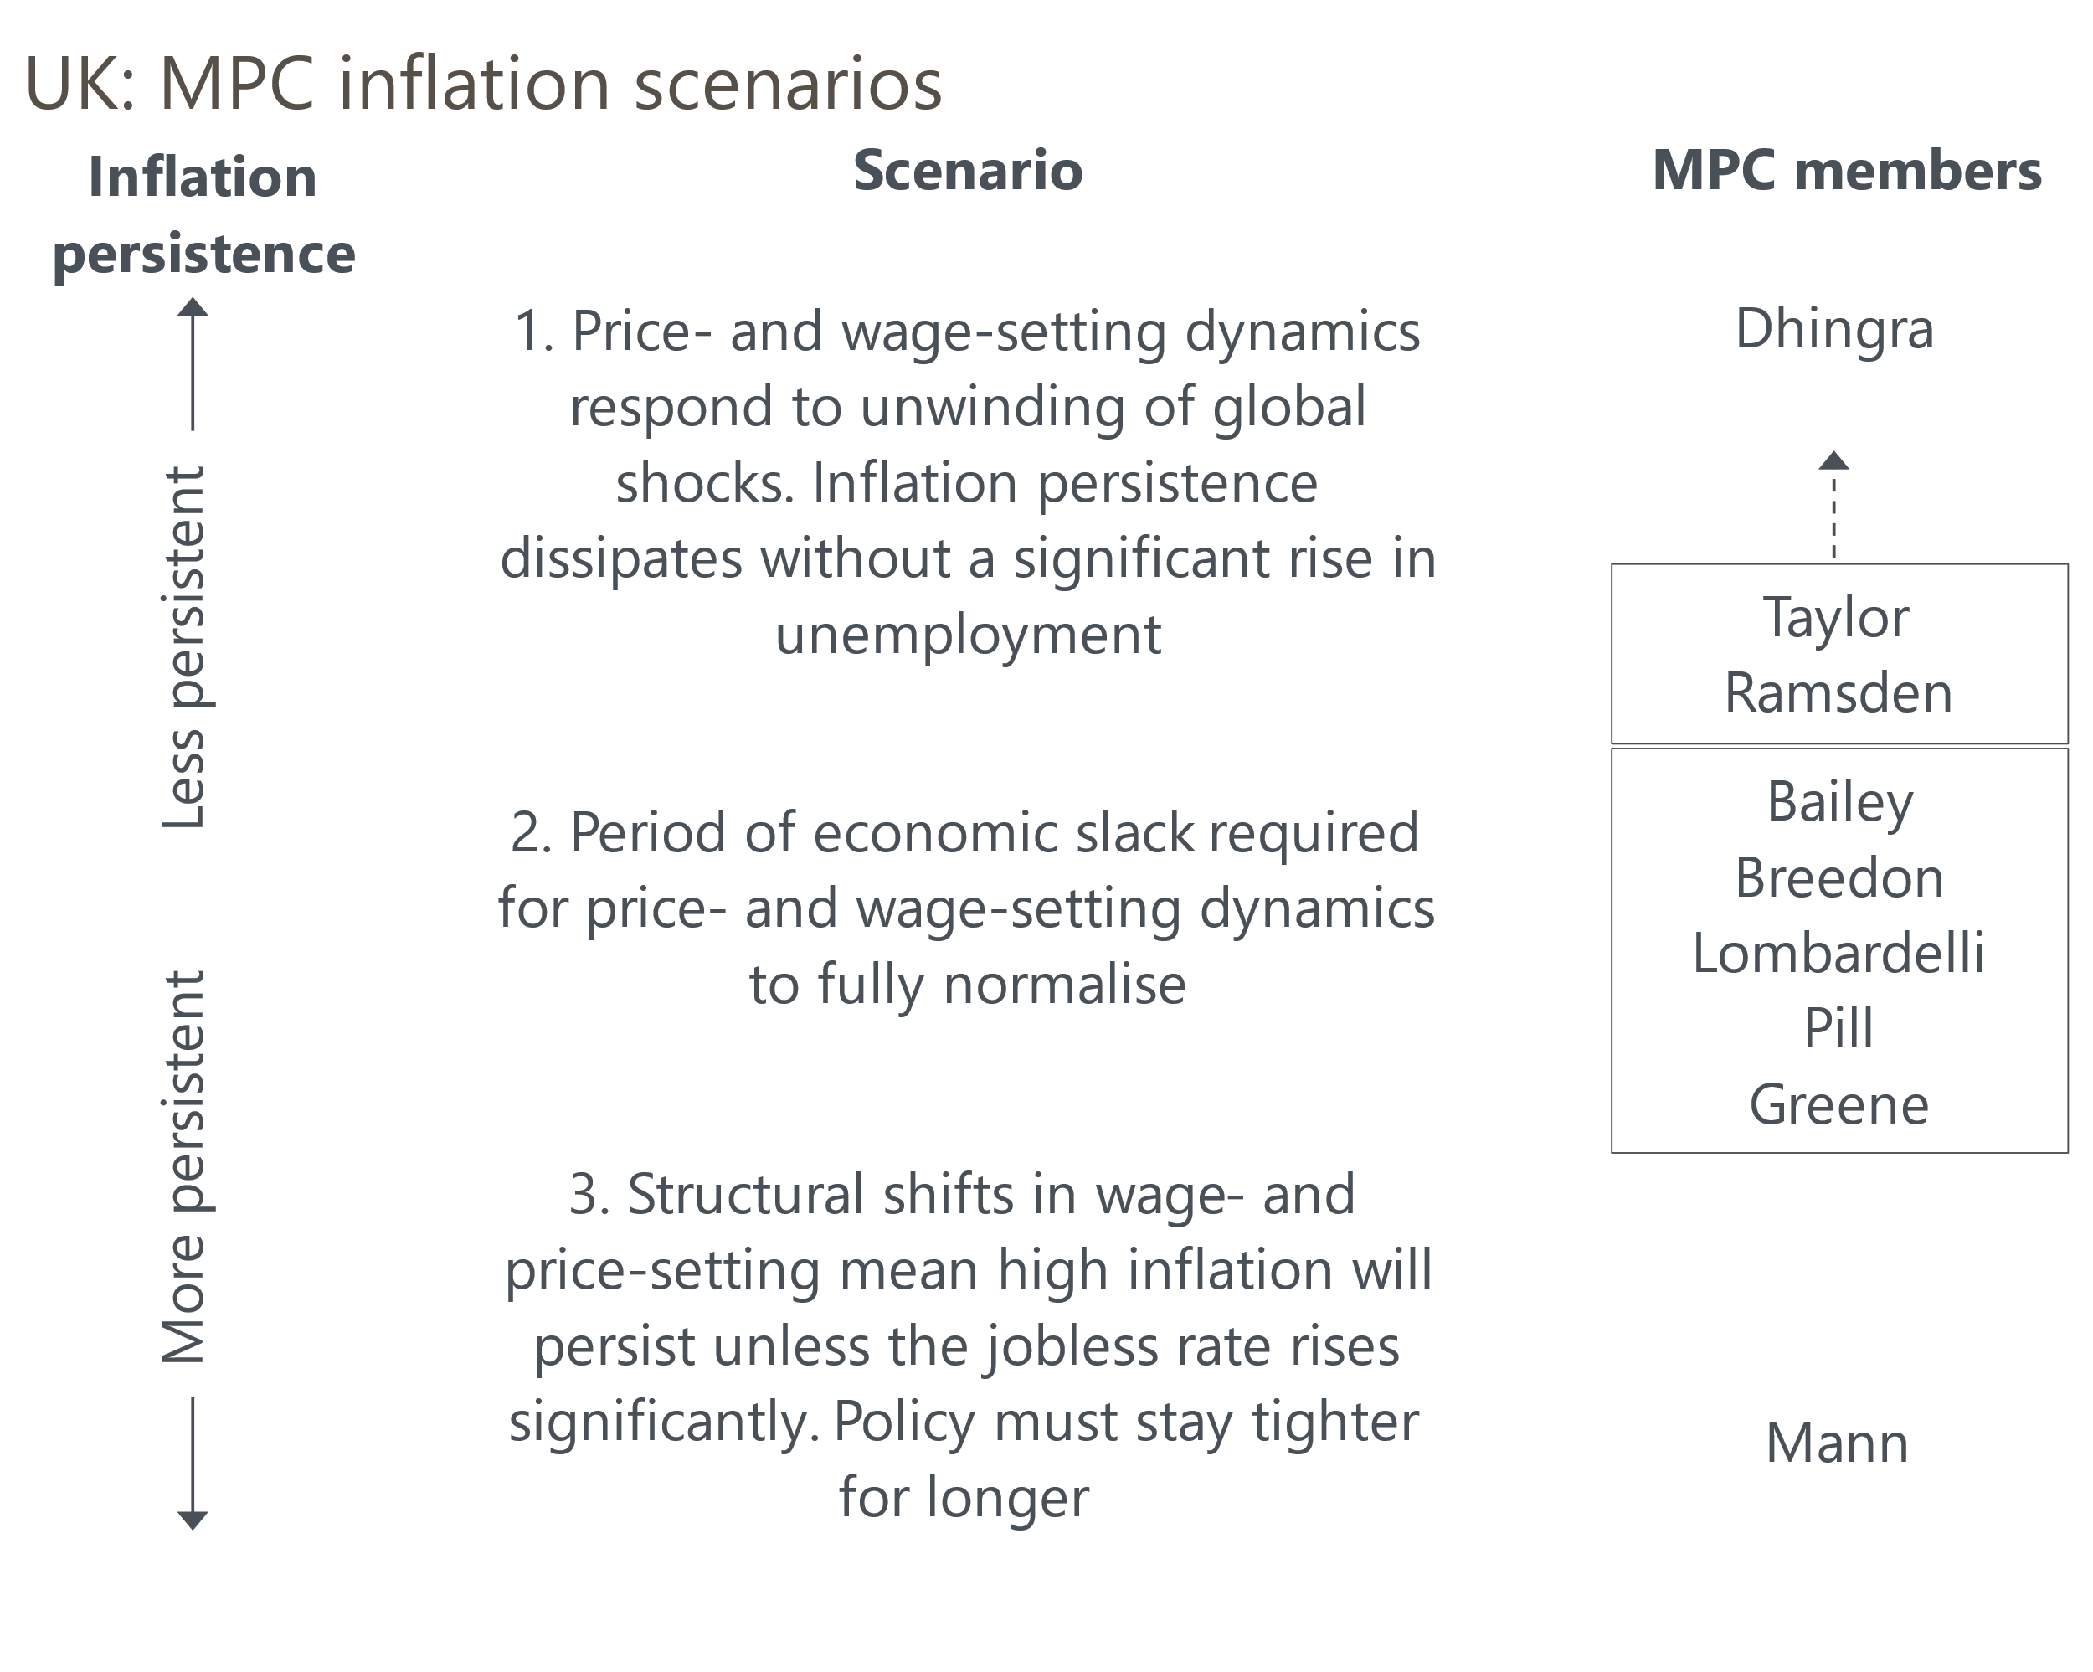
Source: Oxford Economics

Table 1: Key comments by MPC members since the November meeting
Speaker and link | Date | Key takeaway
Greene | 5-Dec | Greene argued that services inflation has remained stubbornly high because though wage growth has been coming down, it was not falling "as quickly as I would have liked". She also warned that the rise in national insurance contributions could push up inflation.
Bailey | 4-Dec | Interviewed as part of the Financial Times' Global Boardroom Conference, the Governor gave the impression that the mid-range inflation scenario was most likely to play out. Bailey also highlighted April's increase in employers' NICs as the main source of uncertainty and said the MPC would have a better idea of how this was playing out in the spring.
Pill | 26-Nov | The BoE's Chief Economist played down the importance of the Budget as a driver of the inflation outlook, arguing that while the policies might add 0.5ppts to inflation in the shorter-term, that would "wash out as we go to the more policy-relevant medium-term horizons".
Lombardelli | 25-Nov | Lombardelli argued that while the risks to inflation are broadly balanced, the potential consequences of the upside risks are more serious. In a subsequent interview with the Financial Times, she expressed concerns about the stickiness of services inflation and the tightness of the labour market.
Dhingra | 25-Nov | Dhingra was characteristically dovish, arguing that the UK no longer looked like an inflation outlier among the advanced economies.
Ramsden | 20-Nov | The Deputy Governor said the MPC's central forecast was "plausible" but argued "it is as least as likely that the disinflationary process sustains its recent trend". Ramsden vowed to be "watchful and responsive" and said he would vote for faster rate cuts when the uncertainties around inflation persistence had diminished.
Taylor | 19-Nov | Taylor said that his "views skew to the downside risk" and that the MPC could loosen policy more quickly than the 100bps of cuts which were embedded in the market curve at the time.
Mann | 19-Nov | Mann said data from the BoE's Decision Maker Panel, which showed price and wage expectations of consumer-facing firms plateauing at high rates, was indicative of the persistence of embedded inflation lasting for longer.
Source: Oxford Economics
We think December's meeting is likely to see a repeat of September's 8-1 vote to keep rates on hold, with Swati Dhingra the sole dissenter. The most likely vote switchers are Ramsden and Taylor. But while both have spoken favourably of the more benign inflation scenario, they've also talked of the need for gradualism and given little indication that a switch of vote could be imminent.
Equally, the economic data published since the November meeting offered only weak support for changing the tempo of rate cuts. The strongest argument in favour of a more activist approach has been the slowdown in activity flagged by official data and business surveys. But in both cases, there are reasons to think that the slowdown may not have been as abrupt as the data implies. This was the third successive year that GDP growth has slowed in Q3, hinting at a residual seasonality problem. Meanwhile, business survey data is likely to have been heavily affected by the hit to sentiment from the increase in employers' national insurance contributions announced in the Budget.
On the prices and wages front, last month's outturns for services inflation and private sector pay growth were in line with the BoE's staff forecasts. The committee will see another print for both series just before next week's meeting. Meanwhile, the BoE's Decision Maker Panel for November reported that firms' expectations for selling prices and wage growth over the year ahead had plateaued at relatively high rates (Chart 2).
Chart 2: Expectations for future price and wage growth have levelled off in recent months
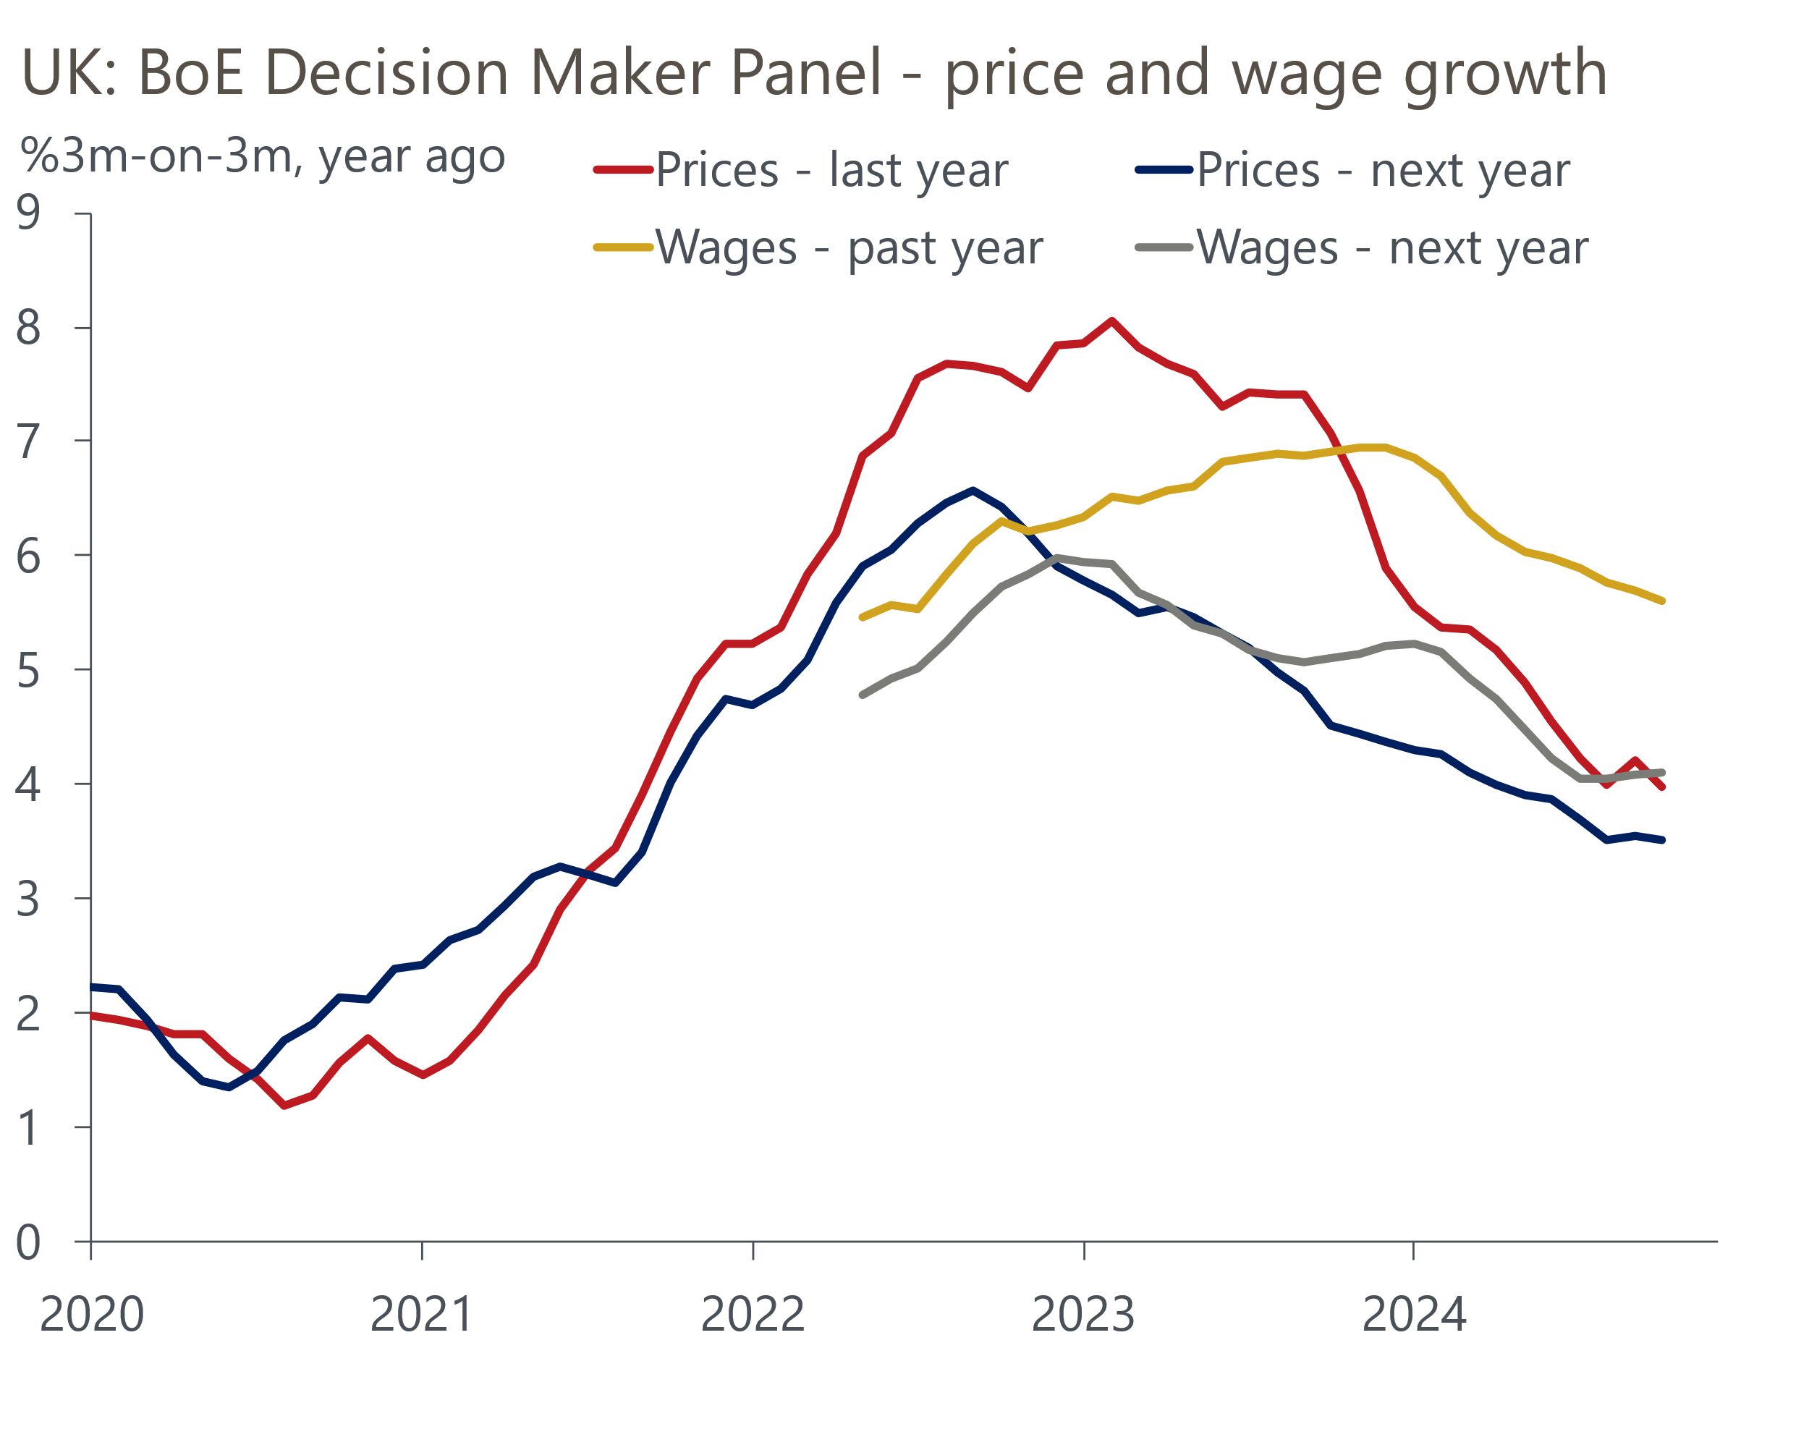
Source: Bank of England Decision Maker Panel
The stabilisation in the survey responses likely reflects the influence of next April's increase in NICs. In a recent interview, Governor Bailey cited this factor as the key domestic source of uncertainty for the inflation outlook. The DMP backed the idea that the policy change will have a wide-ranging impact on the economy, finding that just over half of firms expect to lower margins, raise prices, and reduce headcount. The proportion expecting to offer smaller pay rises was lower, but at 38% was still fairly high.
For the December meeting, the MPC should have early results from the Agents survey of pay deals, which the committee puts considerable weight on. In September, the Agents reported that "contacts have not yet decided on pay awards for 2025, but they expect that pay inflation will fall back to more ‘normal’ levels of around 2%-4%." At this meeting the MPC should have a clearer sense, which could help some members to make a firmer judgement over the persistence of domestic inflation pressures.
However, in his recent interview, Bailey identified a longer timeframe, saying he thought the MPC would have a better idea of how the NICs rise was playing out in the spring. This suggests there will be little jeopardy around the monetary policy decision until at least the March meeting. Expectations that the cut-hold tempo will be maintained will be bolstered if the minutes of December's meeting show the same degree of consensus as in November. The minutes of the last meeting summed up the views of the majority in just six lines, and there was no indication of how the MPC might judge that the scenario probabilities were changing. This suggested no urgency to consider switching up the tempo.
Even with no change in rates at this meeting, the MPC (as at the September meeting) will probably prepare the ground for a cut at the February meeting. One way to achieve that would be to use language along the lines of "The MPC would make a full assessment of recent and prospective developments as part of its forthcoming February forecast round."
Our baseline forecast assumes that the cut-hold tempo is maintained throughout 2025, with cuts in February, May, August, and November. We continue to view a scenario where a more abrupt slowdown in activity encourages the MPC to speed up the pace of rate cuts as being more likely than the three 25bps rate cuts in 2025 that are currently implied by market pricing (Chart 3).
Chart 3: Markets expect three 25bps rate cuts in 2025
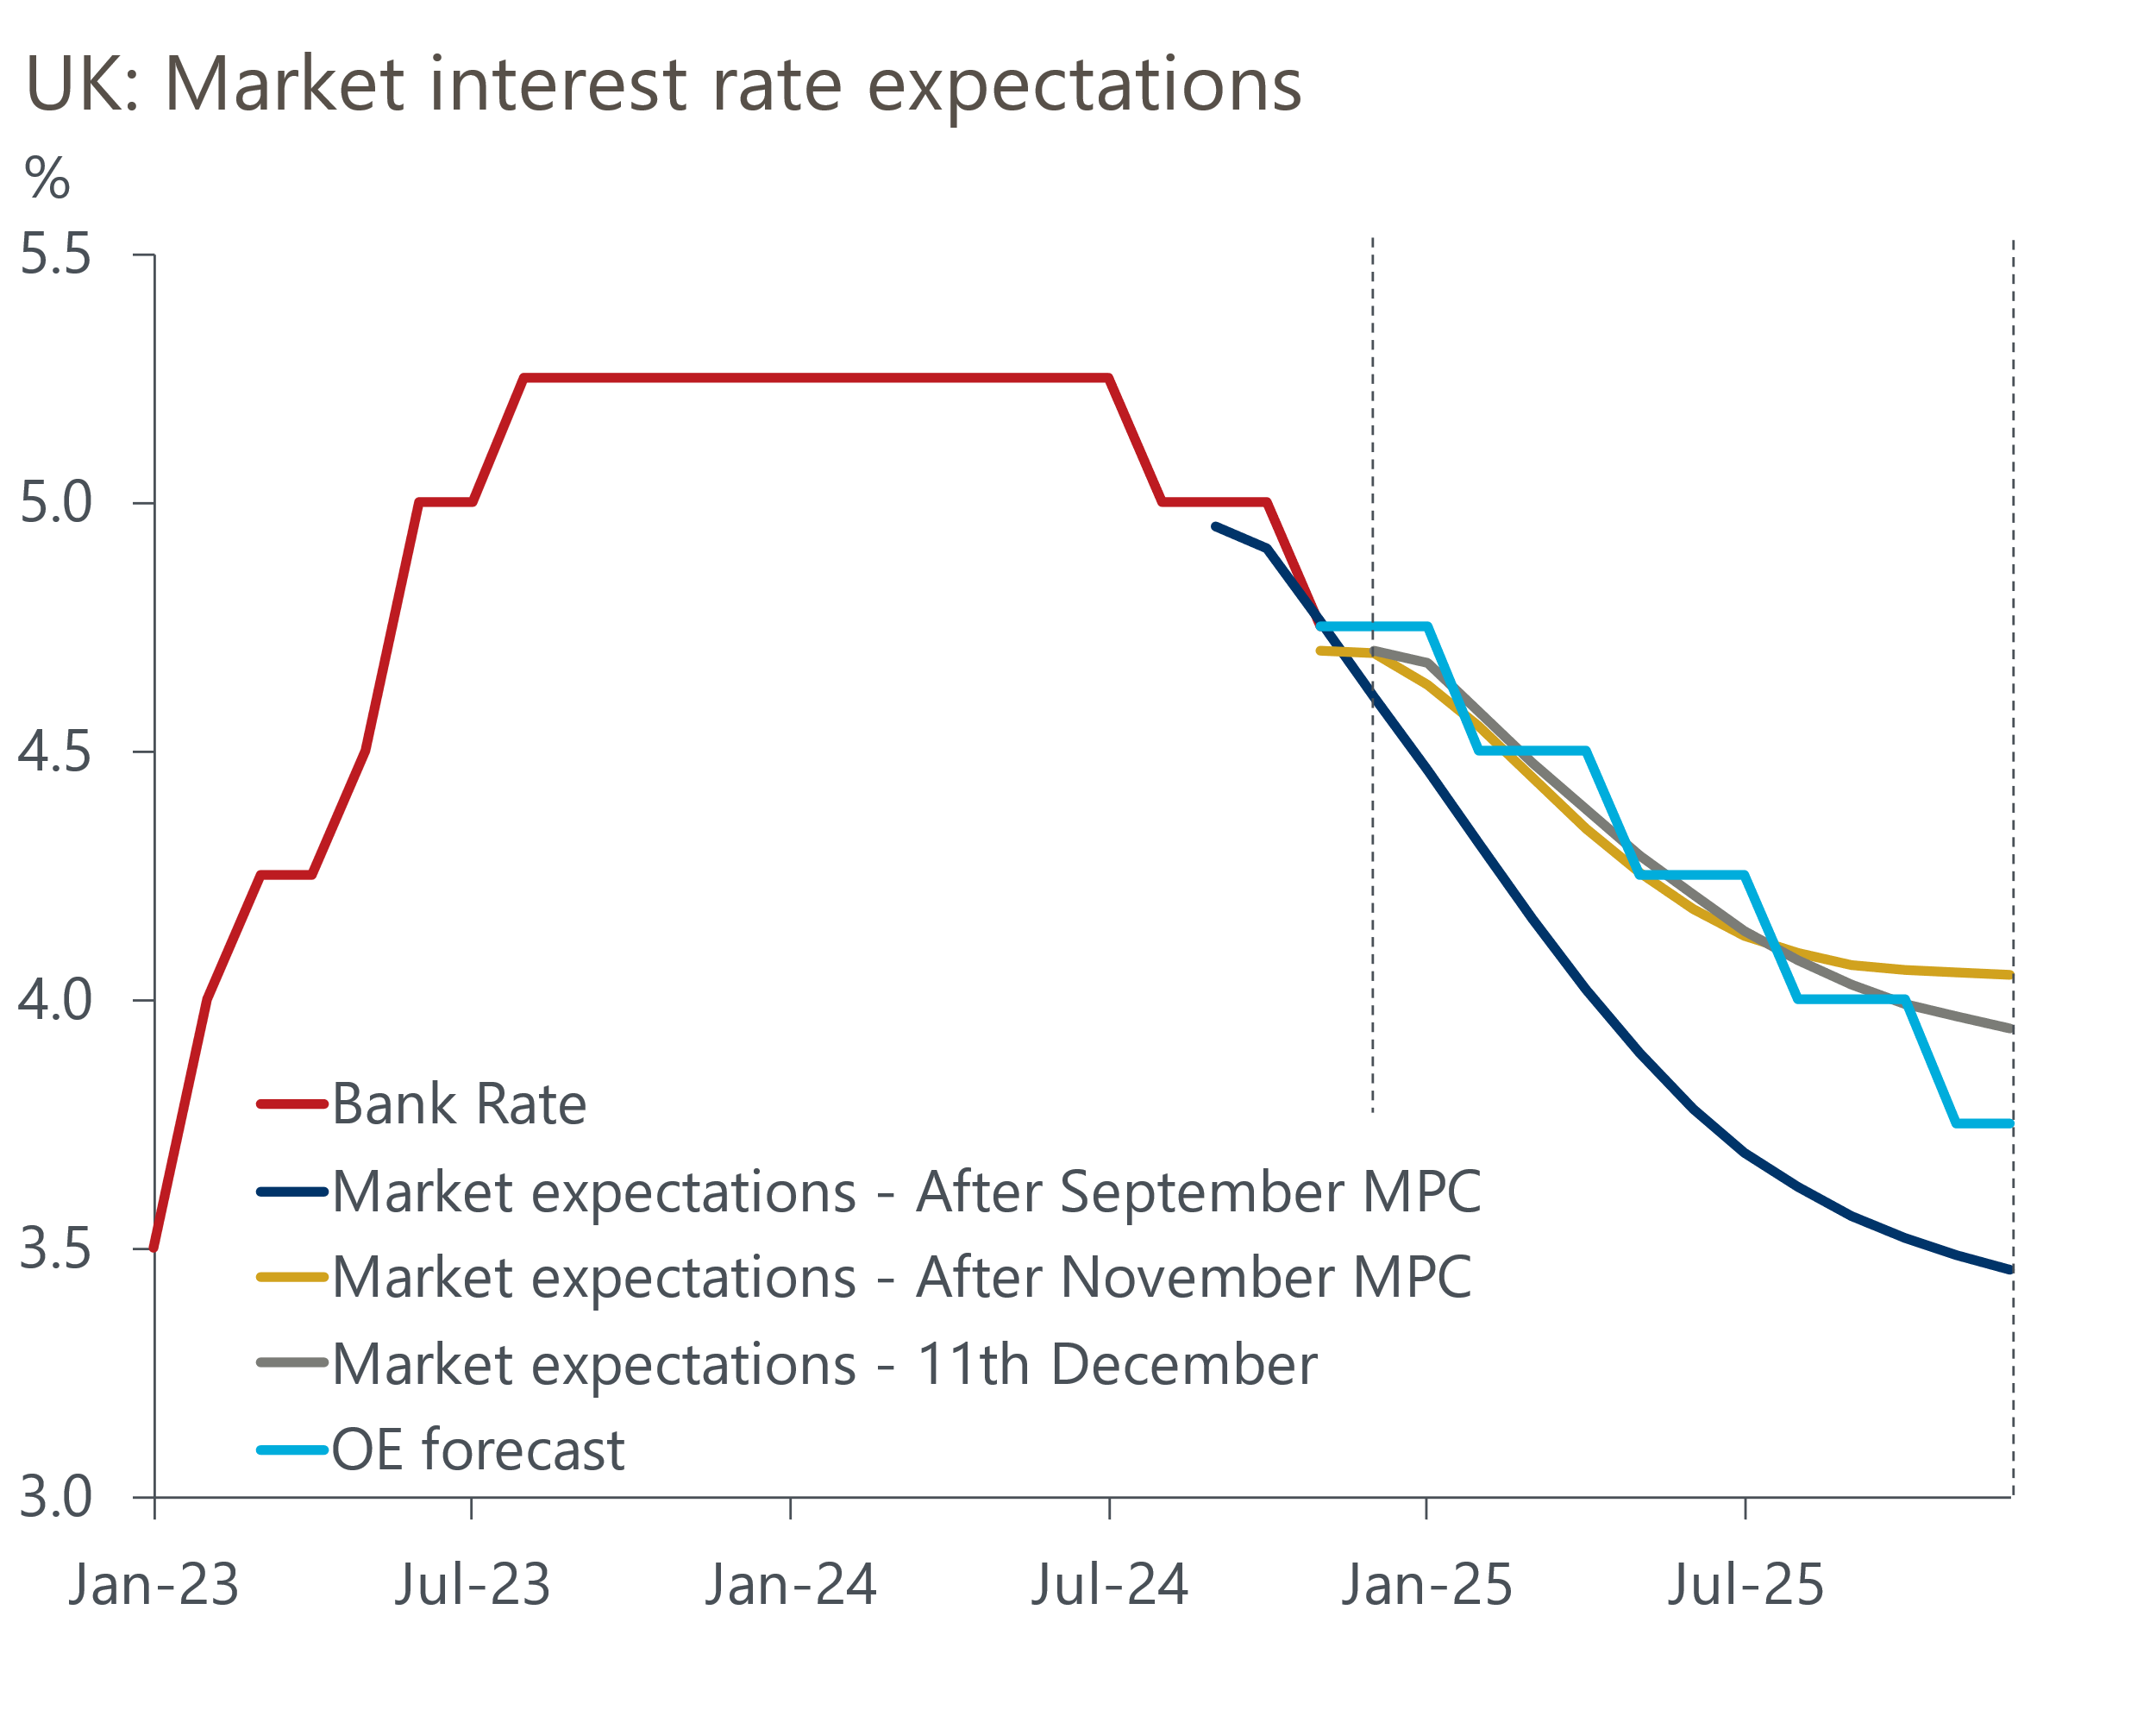
Sources: Oxford Economics, Haver Analytics

